Lesson plans 1, 2, 3, 4, 5 and 6: Finance system

About the lesson
These lessons give students the opportunity to develop a finance system for a business using a spreadsheet. The process encourages an iterative approach, including testing at key stages and versioning.
Students are given a workbook containing data about guests and services and are asked to build a system to a brief, using the skills they learnt in the Introducing spreadsheets and Advanced spreadsheets modules.
Learning objectives
During these lessons, students will demonstrate:
- their ability to use spreadsheet functions to build a finance system for a business
- the iterative approach to development
- the importance of versioning.
National Curriculum
The following subject content from the KS3 National Curriculum is included in this lesson:
- Design, use and evaluate computational abstractions that model the state and behaviour of real-world problems and physical systems
- Understand the hardware and software components that make up computer systems
- Undertake creative projects that involve selecting, using and combining multiple applications, preferably across a range of devices, to achieve challenging goals, including collecting and analysing data and meeting the needs of known users
Links
This module uses the skills developed in the Introducing spreadsheets and Advanced spreadsheets modules. Spreadsheets are a tool used to collect and analyse data in a range of subjects across the curriculum, including maths, the sciences and geography. The skills learned through completing this module should equip students with the skills to use spreadsheets effectively in any other subject and in a range of KS4 IT courses.
Key terminology
iterative approach to project development, CONCATENATE, ROUNDUP, spreadsheet, formatting, VLOOKUP, absolute cell reference, replication, COUNTA, COUNTIF, drop-down list, Goal Seek
Teaching and learning activities
Share the objectives for the lesson with students (Slide 2 of Lesson presentation).
Starter
Introduce students to the project (Slide 3 and page 202).
Explain that the finance system students will be building will include an invoice and a summary of the hotel's accounts and introduce students to these documents (Slides 4–6 and page 202).
Explain how to work with multiple spreadsheets in a workbook and how to use the CONCATENATE and ROUNDUP functions (Slides 7–11 and page 202–203, plus Video 2.1).
Ask students to complete Project 2: Finance system (Worksheet 2.1 and Excel workbook 2.1 or Google Sheets workbook 2.1, slide 12).
- Students should follow the tasks on the worksheet to develop a finance system for a small hotel, working at their own pace. They should be encouraged to save versions of their solution at key points along the way.
- Make all the videos from the Introducing spreadsheets and Advanced spreadsheets modules, as well as Video 2.1, available to students who need help.
Answers
Part 1
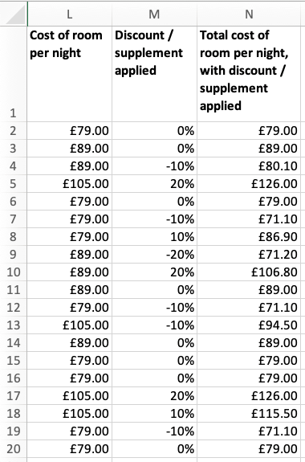
- Students should add seven columns to the 'Guests' tab, with headings similar to those given in Worksheet 2.1.
- Make sure that the correct function has been entered into cell L2: =VLOOKUP( I2, Services!$A$2:$B$4, 2 ). Check that this has been replicated to cells L3 to L20 and that the data has been formatted as currency.
- Make sure that the correct function has been entered into cell M2: =VLOOKUP( J2, Services!$A$9:$B$13, 2 ). Check that this has been replicated to cells M3 to M20 and that the data has been formatted as percentages with no decimal places.
- Make sure that the correct formula has been entered into cell N2: =L2+(L2*M2). Check that this has been replicated to cells N3 to N20 and that the data has been formatted as currency.
Part 2
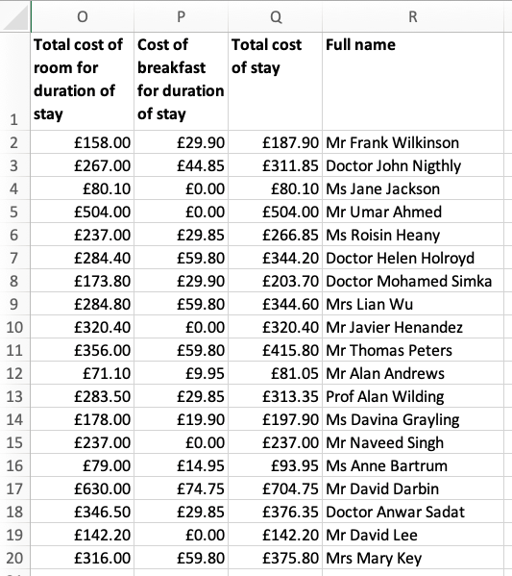
- Make sure that the correct formula has been entered into cell O2: =N2*H2). Check that this has been replicated to cells O3 to O20 and that the data has been formatted as currency.
- Make sure that the correct formula has been entered into cell P2: =VLOOKUP( K2, Services!$D$2:$E$4, 2)*H2. Check that this has been replicated to cells P3 to P20 and that the data has been formatted as currency.
- Make sure the correct formula has been entered in cell Q2: =O2+P2. Check that this has been replicated to cells Q3 to Q20 and that the data has been formatted as currency.
- Make sure the correct function has been entered in cell R2: =CONCATENATE( B2, " ", C2, " ", D2 ). Check that this has been replicated to cells R3 to R20.
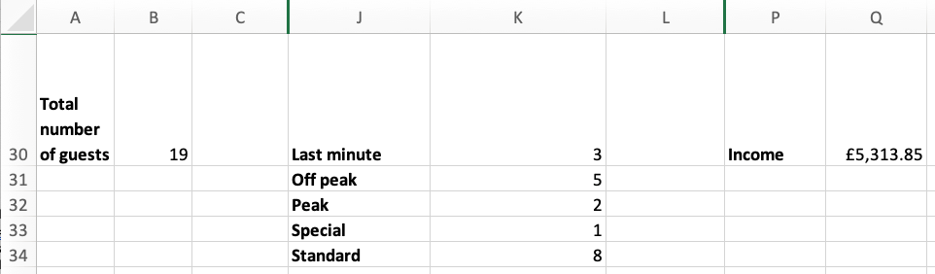
- Check that the correct function has been entered somewhere below the guest details, with an appropriate label: =COUNTA(B2:B20).
- Check that the correct functions have been entered somewhere below the guest details, with an appropriate label, for example =COUNTIF( J2:J20, "Last minute" ).
- Check that the correct formula has been entered somewhere below the guest details, with an appropriate label: =SUM(Q2:Q20).
Part 3
- Students should create a third tab called 'Invoice'.
- The invoice should have a hotel name as a prominent header filling columns A and B.
- and 15.
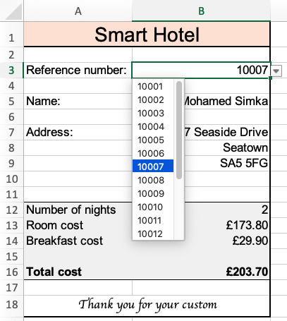
- Check that the correct function has been entered: <code>=VLOOKUP( B3, Guests!$A$2:$R$20, 18 )</code>.
- Check that the correct functions have been entered: =VLOOKUP( B3, Guests!$A$2:$R$20, 8 ), =VLOOKUP( B3, Guests!$A$2:$R$20, 15 ), =VLOOKUP( B3, Guests!$A$2:$R$20, 16 ) and =VLOOKUP( B3, Guests!$A$2:$R$20, 17 ).
- Students should format the invoice, so that it can be printed for guests when they check out.
Part 4
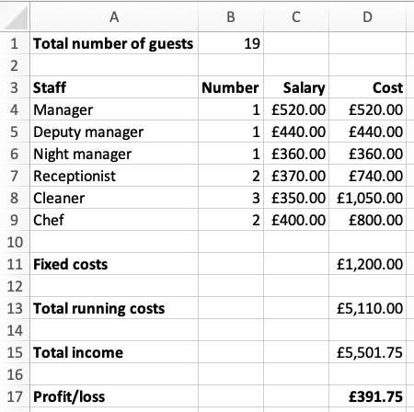
- Students should create a fourth tab called 'Accounts'.
- Check that the correct link has been entered, for example =Guests!B30.
21., 22. and 23. Check that students have correctly entered the data requested.
- Check that the correct formula has been entered: =ROUNDUP(B1/7, 0).
- Check that the correct formula has been entered (=ROUNDUP(B1/10,0)) and that the cell formatting has been adjusted to show no decimal places.
- Check that the correct function has been entered in cell C4 and the correct formulae have been entered in cell D4: =VLOOKUP( A4, Services!$G$2:$H$7, 2 ) and =C4*B4. Check that these have been replicated to cells C5 to C9 and D5 to D9.
- Check that the correct link has been entered, for example =Services!H9.
- Check that an appropriate label has been added and the correct formula has been entered: =SUM(D4:D11).
- Check that an appropriate label has been added and the correct link has been entered, for example =Guests!Q30.
- Check that an appropriate label has been added and the correct formula has been entered: =D15-D13.
Part 5
- a. The hotel will make a profit of £1048.45. Make sure that the total number of guests shows correctly as 25; the formula from step 9 will need updating. Make sure that the total income includes the total cost of the stay for the additional guests; the formula from step 11 will need updating.
- The hotel will make a profit of £847.65. Check that the 'Special' discount rate on the 'Services' spreadsheet has been changed to -15%.
- The hotel will make a profit of £1210.05.
- The 'Standard' room rate should be £73.75.
- Responses will vary depending on the scenarios explored by students. Minimising discounts and making sure all guests pay for breakfast will increase profit.
- 32. Again, responses will vary depending on the scenarios explored by students.
Recommendations should be justified with evidence from the spreadsheet, and this might be in the form of screenshots showing the changes made and the profit/loss generated as a result.
End-of-KS3 assessment
Use the 'Project 2' tab of Projects: Assessment (Excel) or Projects: Assessment (Google Sheets) to mark students' programs.
Plenary
Give students five minutes at the end of each lesson to ask their classmates for help on anything they are struggling with. This could be done as a class, in small groups or in pairs.
or in pairs.
Homework
If appropriate, ask students to continue working on their project.
Stretch and support activities
The activities in this module are intended to stretch students so most will require all the time available and some may only be able to complete parts of the activity.
Some students may find these activities straightforward and complete the tasks very quickly. These students should be encouraged to experiment and design, write and test their own additional features.
Some students may find it challenging to complete all the elements of the activities and should be encouraged to concentrate on getting the early parts of the activity as complete as possible. It may be necessary to provide some additional support for students who are finding the activity challenging by using the indicative solutions with parts edited out for them to complete.
A number of short and informative videos can be found online that demonstrate the use of features in spreadsheets, such as https://www.youtube.com/c/microsoft365/playlists?view=50&sort=dd&shelf_id=5 for Microsoft Excel and https://www.youtube.com/channel/UCco3PQfioWg5uFBxi1ndb2A for Google Sheets.
Step-by-step instructions for functions in Microsoft Excel can also be found at https://www.w3schools.com/excel/excel_functions.php

